Project

On

Water Pollution Visual Classification Model

Submitted by

Jai Surya Parabhakaran

Guide

Raja Hashim Ali

Department Of Data Science

University Of Europe For Applied Science

2026 - 2027

- Background and motivation:

Clean water is something many of us take for granted, yet water pollution remains one of the most serious environmental problems facing the world today — threatening the health of communities, wildlife, and entire ecosystems. Checking water quality the traditional way means sending people out to collect samples and run lab tests, which takes time, costs money, and simply can't keep up with the scale of the problem. That's where technology can make a real difference. Deep learning, and specifically Convolutional Neural Networks, can be trained to look at images of water and detect signs of pollution automatically — the same way a trained eye might, but faster and at a much larger scale. This project was born out of that idea: to build a simple but effective system that can classify water as polluted or clean from images alone, making pollution detection more accessible and practical.

- Problem Statement:
Water pollution kills. It contaminates drinking sources, destroys aquatic life, and affects millions of people who have no idea the water around them is unsafe. The frustrating part is that we have the technology to do better — we're just not using it in the right way yet. Traditional water testing is stuck in the past, relying on manual processes that are too slow and too costly to scale. This project proposes a smarter approach: using deep learning to automatically classify water images as polluted or clean, so that detection becomes something that can happen anywhere, anytime, without waiting for a lab result.

- Selected Dataset:
The dataset is designed for image classification tasks in environmental monitoring using Convolutional Neural Networks (CNNs) and transfer learning models. It can be used for binary classification, deep learning experiments, and educational machine learning projects.
Dataset Link: https://www.kaggle.com/datasets/ferix01/water-pollution-classification-dataset
- Dataset Description:
Datasetname : water pollution classification dataset
Source : Kaggle
Number Of Class : 2
Class names : polluted, clean
Total Images : 301 (154 + 147)
Polluted Images : 154
Clean Images : 147
Image Type : RGB (colour images)
- Research Questions:
RQ1. Can a custom CNN model trained from scratch accurately classify water images as polluted or clean?
RQ2. Does transfer learning with MobileNetV2 perform better than a custom CNN when the dataset is small (301 images)?
RQ3. How effective is data augmentation (flip, rotation, zoom, contrast) in improving the generalization of the CNN model?
RQ4. Which evaluation metric — accuracy, F1-score, or confusion matrix — gives the most reliable measure of model performance on an imbalanced water pollution dataset?
RQ5. What are the key limitations of using deep learning for water pollution classification when the training data is limited?
6) Expected result:
The expected outputs of this project include accuracy and loss curves for both models, showing how well each one learned over 10 training epochs. The custom CNN is expected to struggle, producing a low test accuracy of around 48% and failing to correctly classify clean water images at all — a clear sign that training from scratch on a small dataset is not enough. MobileNetV2 on the other hand is expected to perform exceptionally well, achieving around 96% accuracy with strong precision and recall across both classes, supported by a clean confusion matrix and consistent classification report. Finally, a side by side model comparison table will clearly highlight the advantage of transfer learning over a custom built CNN when working with limited data."
7) Proposed Methodology:
Step 1- Data Collection The dataset was collected from Kaggle, consisting of 301 RGB images across two classes — Polluted and Clean water images.
Step2 - Data Preprocessing All images were resized to 224×224 pixels and loaded using TensorFlow's image_dataset_from_directory. The dataset was split into three subsets — 70% for training, 15% for validation, and 15% for testing. Pixel values were normalized from 0–255 to 0–1 using a Rescaling layer.
Step3 - Data Augmentation To improve generalization and reduce overfitting on the small dataset, four augmentation techniques were applied during training — random horizontal flip, random rotation (20%), random zoom (20%), and random contrast (20%).
Step 4 - Performance Optimization The dataset pipeline was optimized using cache(), shuffle() and prefetch() to speed up training and reduce memory bottlenecks.
Step 5 — Custom CNN Model A custom CNN was built from scratch with 3 convolutional blocks (32, 64, 128 filters), each followed by MaxPooling. A Dense layer of 128 neurons with Dropout (0.5) was added before the final sigmoid output layer. The model was compiled with Adam optimizer and binary crossentropy loss, trained for 10 epochs.
Step 6 — Transfer Learning with MobileNetV2 MobileNetV2 pretrained on ImageNet was used as the base model with frozen weights. A GlobalAveragePooling2D layer, Dense layer (128 neurons), Dropout (0.3), and sigmoid output layer were added on top. The model was compiled and trained for 10 epochs using the same dataset.
Step 7 — Evaluation Both models were evaluated on the test set using accuracy, loss, precision, recall, F1-score, confusion matrix, and a final model comparison table
8) CNN model design :
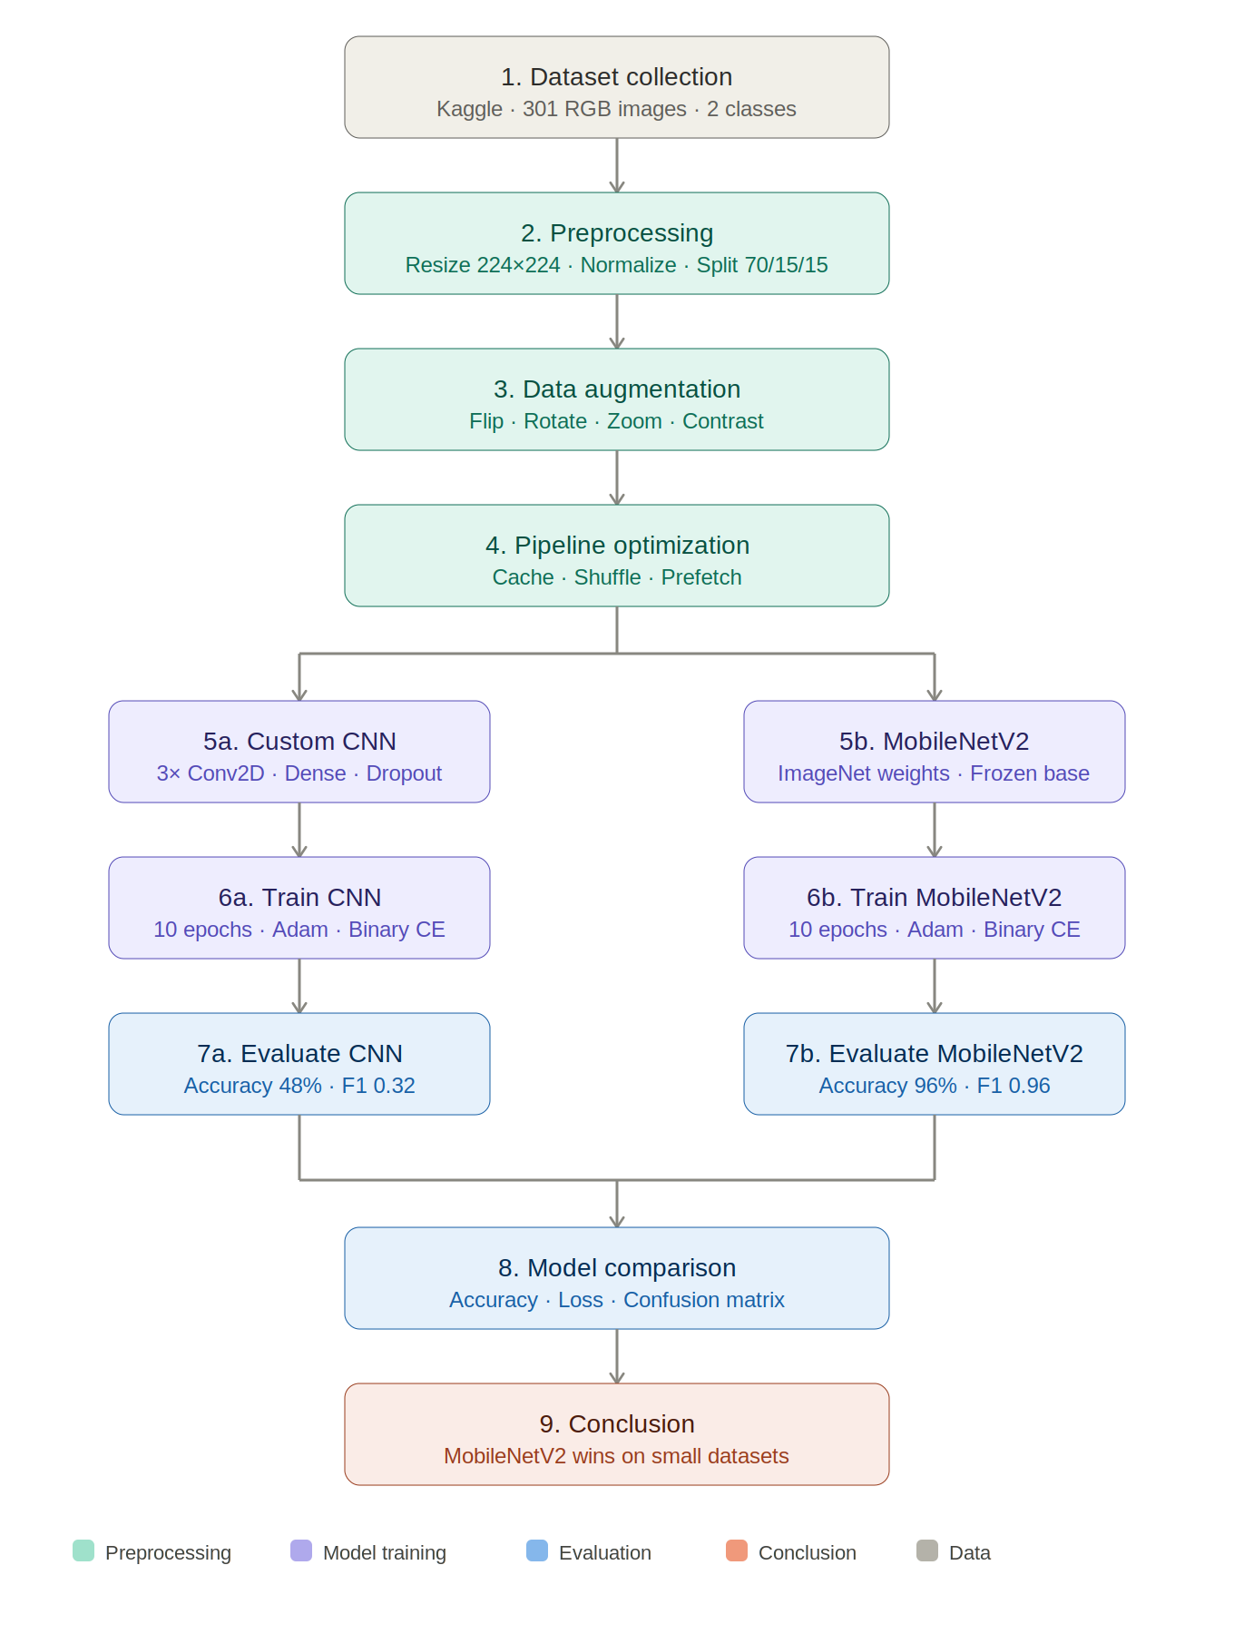

9) Transfer Learning - MobileNetV2
Instead of building everything from scratch, we decided to take advantage of a model that already knows a lot about images — MobileNetV2. This model was originally trained on ImageNet, a massive dataset containing over a million images across 1,000 different categories. That means it already understands how to detect edges, textures, shapes, and patterns in images before we even show it a single water photo.
The idea behind transfer learning is simple — why start from zero when you can borrow knowledge from somewhere else? So we took MobileNetV2, froze all its existing weights so they wouldn't change, and added our own small set of layers on top to teach it the difference between polluted and clean water specifically.
The custom layers we added were a GlobalAveragePooling2D layer to summarize the features, a Dense layer with 128 neurons to learn the patterns, a Dropout layer to prevent overfitting, and finally a Sigmoid output layer to make the final prediction.
The results proved that this approach was the right call — MobileNetV2 achieved 96% accuracy on the test set, compared to just 48% from the custom CNN trained from scratch. With a small dataset of only 370 images, transfer learning made all the difference.
10) Evaluation Metrix:
To understand how well our models were actually performing, we didn't just rely on a single number. We used a combination of metrics that together give a much clearer and honest picture of the results.
Accuracy:
simply put, out of all the images the model saw, how many did it get right? It's the most straightforward metric but can be misleading when classes are imbalanced, so we didn't stop there.
Precision:
when the model said an image was polluted, how often was it actually polluted? This matters because falsely labeling clean water as polluted could cause unnecessary panic.
Recall:
Out of all the actually polluted images, how many did the model successfully catch? This is critical in a real-world pollution detection scenario because missing a polluted water source could be dangerous.
F1-score:
F2 - score brings precision and recall together into one balanced number. It's especially useful here because our dataset is small and slightly imbalanced, making it a more reliable metric than accuracy alone.

confusion matrix:
It visually see exactly where each model was making mistakes — which images were correctly classified and which ones were confused with the wrong class.
Finally, we compared both models side by side in a model comparison table showing test accuracy and test loss, making it easy to see at a glance that MobileNetV2 significantly outperformed the custom CNN.
11) Expected Figures and tables
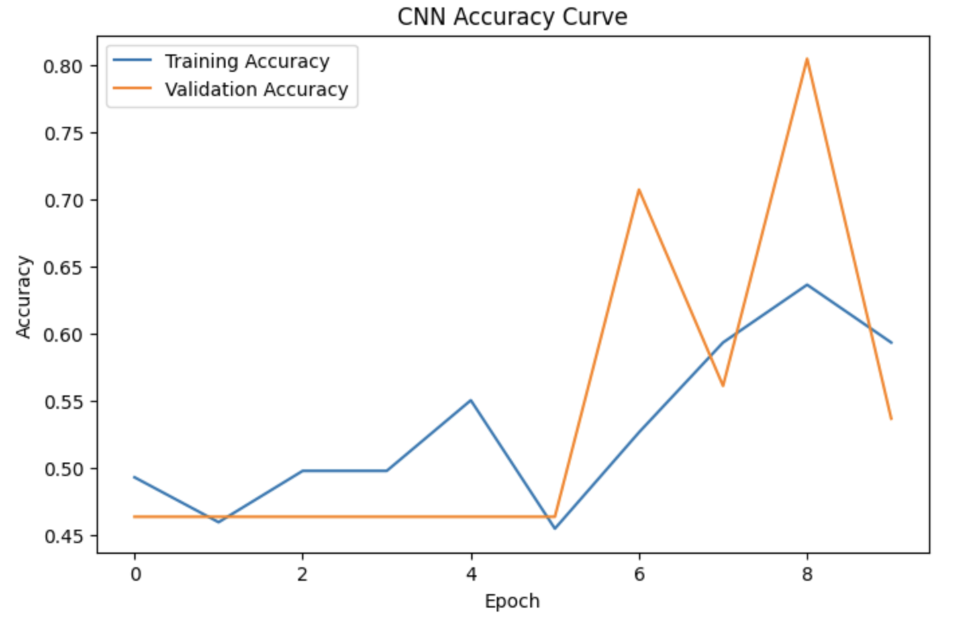
Figure 1: cnn_accuracy_curve
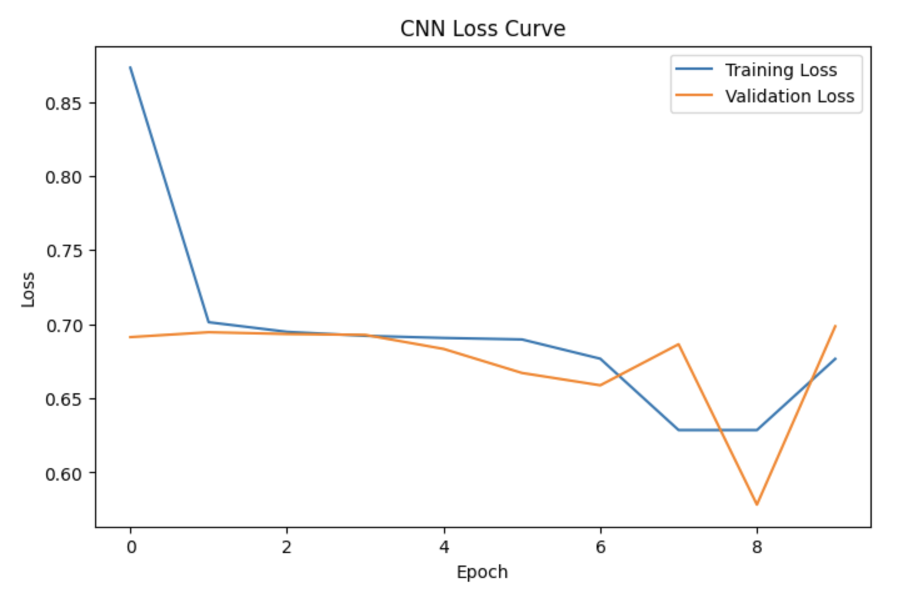
Figure 2: cnn_loss_curve

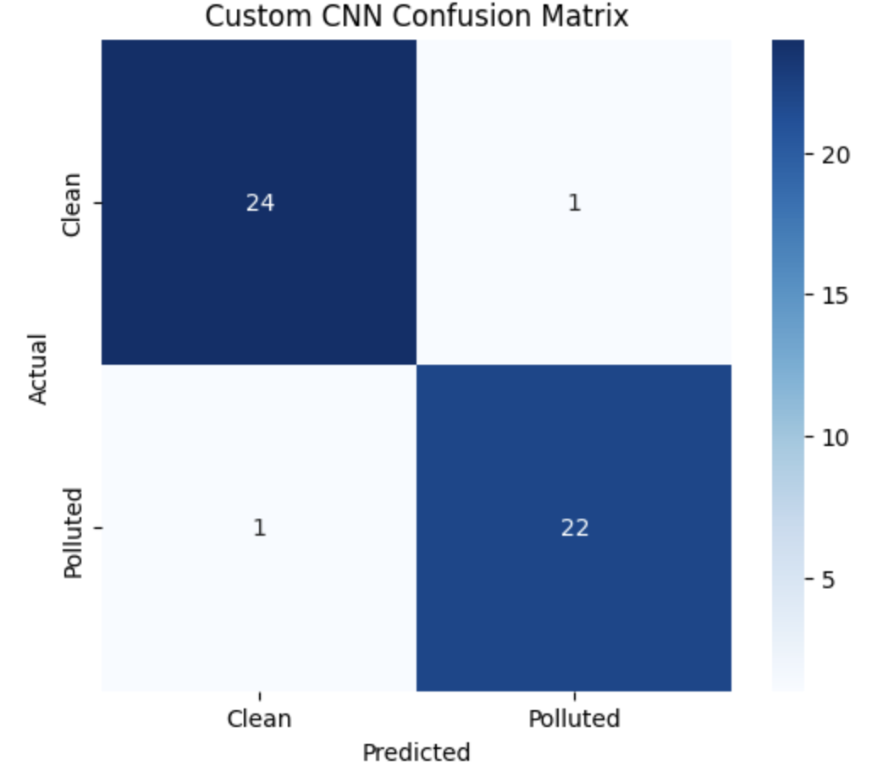
Figure 3: cnn_confusion_matrix

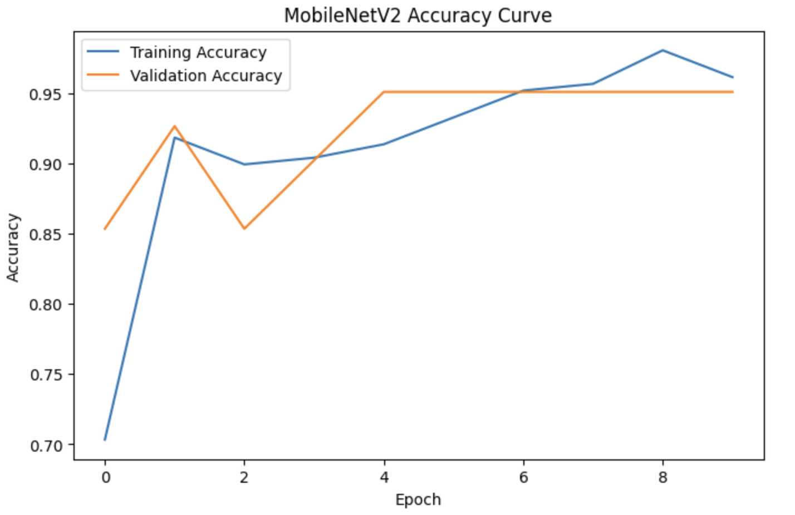
Figure 4: mobilenet_accuracy_curve

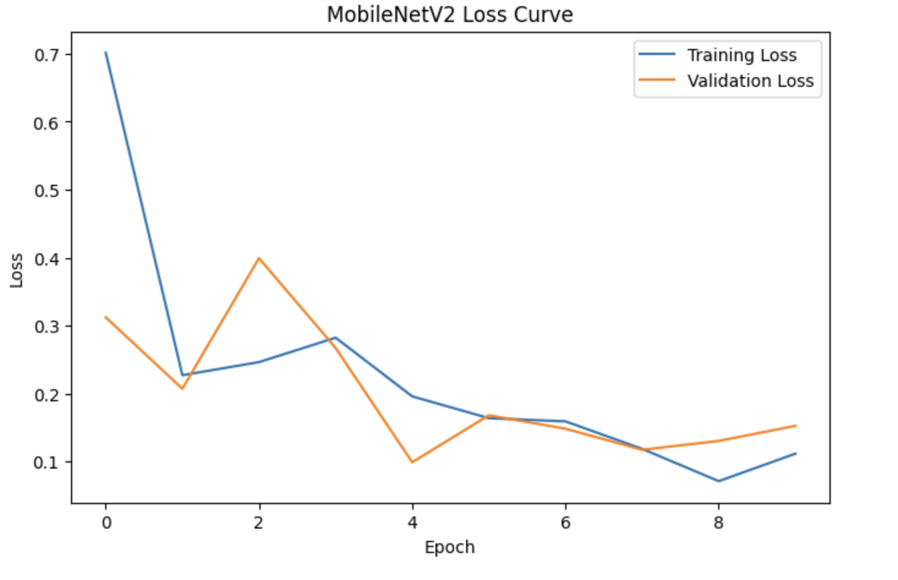
Figure 5: mobilenet_loss_curve

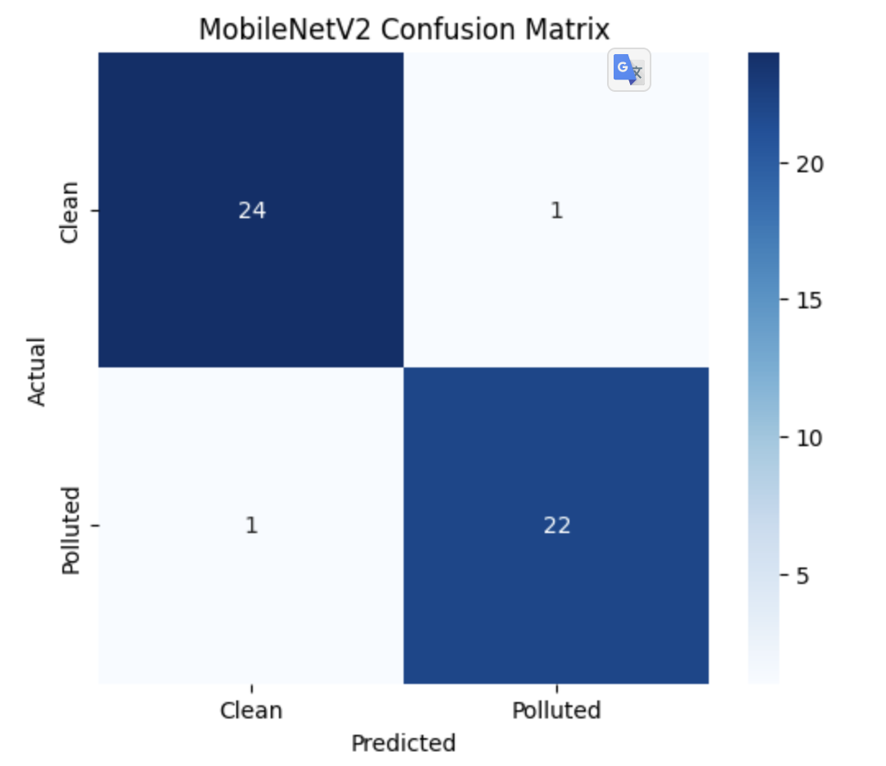

Figure 5: mobilenet_confusion_matrix

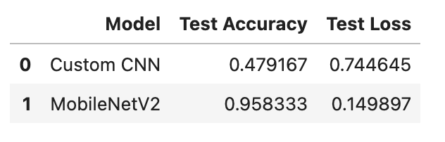
Figure 6: Model Comparison

